ITM 311

SPRING 2016

Alejandro Gomez

APRIL 29, 2016

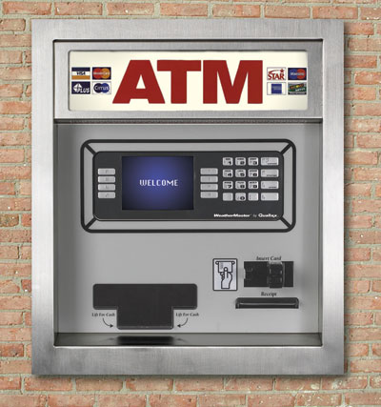

OBJECTIVES and SCOPE of PROJECT

Client Specifications:

You are to program a virtual ATM machine for the IIT Bank and Trust Company. The client wants a GUI for its virtual ATM. The program will allow a user to enter their personal pin number (only 4 numbers allowed from 0010 to 8888). The user then must choose which account they would like to make a transaction: Savings Account or Checking Account, or Loan Payment (such as a mortgage, a car loan, or a student loan). If the user chooses a savings account, then the allowed transactions are either to add money to the saving account, or to withdraw money from the savings account. A balance must be given to the user at the end of the transaction. Assume that the user has a starting balance of $3000 in each of their accounts. Error trapping: if a balance goes below $500, then an alert to the user will be issued.

Objective: Create a Virtual ATM for the client.

Client Information

Name: IIT Bank and Trust Company

Location: 3300 So. Federal, Chicago, IL 60616

Telephone: 312 – 567 - 3000

Contact Person: Katherine Papademas

Requirements for the Virtual ATM

1. Create personal pin number per user (limit 0010 to 8888).

2. Create Savings Account with initial balance of $3000.

3. Create Checking Account with initial balance of $3000.

4. Create Loan Account with initial balance of $10,000.

5. Transactions

a. Savings deposits and withdrawals

b. Checking deposits and withdrawals

c. Loan payments

d. Balance for all accounts

RESOURCES: TIME, MONEY, PEOPLE

TASKS, OBJECTS, EVENTS

|  |  |  |
| --- | --- | --- |
| TASKS | OBJECTS | EVENTS |
| Create Personal Pin | Int pin = 1234; | Checking pin |
| Create accounts | Double[] savings; checking, loan | Change value of Jtext fields |
| Create panel | Pnl | Panel changes depending on button pressed |
| Create buttons | Bttn 1-8 | When button pressed, pnl/output changes |
| Create text fields | JTextField with,Sav, Che, Lo | Where input goes |
| Create labels | JLabel greet, greet2, S, C, L, one, two, three | Identification of account and information |
| Create boolean | S, c, l | To check which account is being accessed |

Website of interest: <https://lbpe.wikispaces.com/Toe+Charts>

MS Project -Learn

MS VISIO REPRESENTATION OF GUI

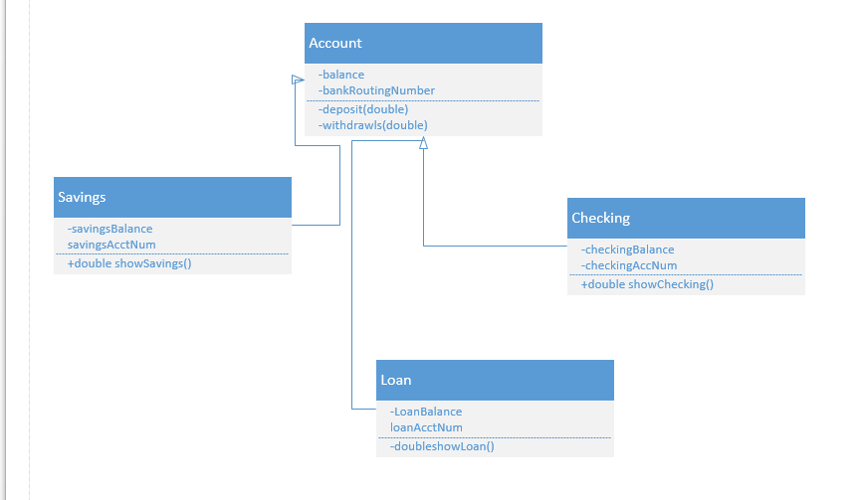

Suggestion1-get from the school

Suggestion2- go to school and complete project

Suggestion3-http://www.draw.io/

Suggestion4-MS Paint

UML DIAGRAM OF SYSTEM

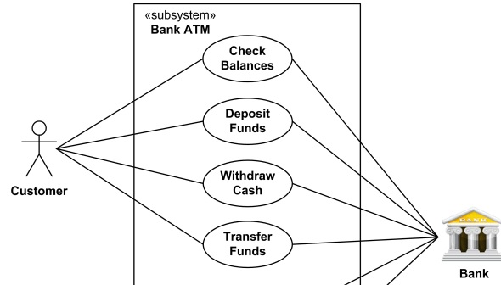

Customer-> Actor

Bank->Actor

Adjust the diagram/create new diagram to specify the system 

MS VISIO OF FLOWCHART

PSEUDOCODE

JAVA CODE FOR VIRTUAL ATM

Don’t forget to submit the virtualATM.java

**import** java.awt.Container;

**import** java.awt.FlowLayout;

**import** javax.swing.*;

**import** java.awt.Font;

**import** java.awt.event.* ;

**import** javax.swing.* ;

**import** java.util.Random;

**import** java.lang.Boolean;

**class** Account **extends** JFrame **implements** ActionListener

{

Container contentPane = getContentPane();

Container pane = getContentPane();

Font headlineFont = **new** Font("Arial", Font.***ITALIC***, 20);

JPanel pnl = **new** JPanel();

JLabel greet = **new** JLabel("Welcome to Bank International!");

JPasswordField pin = **new** JPasswordField(38);

//greet.setFont(headlineFont);

JButton btn = **new** JButton("Click Me");

JLabel greet2 = **new** JLabel("Please choose which one you would like");

JButton btn2 = **new** JButton("Checking");

JButton btn3 = **new** JButton("Savings");

JButton btn4 = **new** JButton("Loan Transaction");

JButton btn5 = **new** JButton("Would you like to Withdrawl?");

JTextField with = **new** JTextField(38);

JButton btn6 = **new** JButton("Would you like to Deposit?");

JTextField dep = **new** JTextField(38);

JLabel S = **new** JLabel("Remaining balance of Savings account");

JTextField Sav = **new** JTextField(38);

JLabel C = **new** JLabel("Remaining balance of Checking account");

JTextField Che = **new** JTextField(38);

JLabel L = **new** JLabel("Remaining balance of Loan account");

JTextField Lo = **new** JTextField(38);

//int[] pins = new int[10];

**int** Pin = 1234;

JButton btn7 = **new** JButton("Enter payment amount:");

JButton btn8 = **new** JButton("Press to go back");

**double**[] saving = {3000,0,0};

**double**[] checking = {3000,0,0};

**double**[] loan = {10000,0,0};

**int** input = 0;

**double** w = 0;

**double** d = 0;

JLabel one = **new** JLabel("This is your checking account");

JLabel two = **new** JLabel("This is your Savings account");

JLabel three = **new** JLabel("This is your Loan account");

Boolean s = **false**;

Boolean c = **false**;

Boolean l = **false**;

**public** Account()

{

**super**("Swing Window");

setSize( 550, 400);

setDefaultCloseOperation( ***EXIT_ON_CLOSE***);

add(pnl);

pnl.add(greet);

pnl.add(btn);

btn.addActionListener(**this**);

btn5.addActionListener(**this**);

btn6.addActionListener(**this**);

btn7.addActionListener(**this**);

btn8.addActionListener(**this**);

setVisible(**true**);

}

**public** **void** actionPerformed(ActionEvent event)

{

//Random rand = new Random();

**if**( event.getSource() == btn)

{

**for** (**int** i =0; i<10;i++)

{

//pins[i] = rand.nextInt((8888 - 0010) + 1) + 10;

//System.out.print(pins[i] + ";");

}

System.***out***.println(" ");

pin.setText(JOptionPane.*showInputDialog*(**this**, "Enter your Pin please", "Input Pin", JOptionPane.***PLAIN_MESSAGE***));

**double** input = Integer.*parseInt*(pin.~~getText~~());

**if**(Pin != input)

{

JOptionPane.*showMessageDialog*(**null**, "Incorrct Pin, Please Try again","Result", JOptionPane.***PLAIN_MESSAGE***);

}

**else**

{

pnl.remove(btn);

pnl.add(greet2);

pnl.add(btn2);

pnl.add(btn3);

pnl.add(btn4);

btn2.addActionListener(**this**);

btn3.addActionListener(**this**);

btn4.addActionListener(**this**);

setVisible(**true**);

}

}

**if**( event.getSource() == btn2)

{

//this is for checking checking

c = **true**;

pnl.remove(greet);

pnl.remove(greet2);

pnl.remove(btn2);

pnl.remove(btn3);

pnl.remove(btn4);

pnl.add(one);

pnl.add(btn5);

pnl.add(with);

pnl.add(btn6);

pnl.add(dep);

pnl.add(S);

pnl.add(Sav);

pnl.add(C);

pnl.add(Che);

pnl.add(L);

pnl.add(Lo);

Che.setText(String.*valueOf*(checking[0]));

Sav.setText(String.*valueOf*(saving[0]));

Lo.setText(String.*valueOf*(loan[0]));

pnl.add(btn8);

setVisible(**true**);

}

**if**( event.getSource() == btn5 && c==**true**)

{

Che.setText(String.*valueOf*(checking[0]));

**double** w = Double.*parseDouble*(with.getText());

System.***out***.print(checking[0]);

**if**((checking[0] - w )<0)

{

JOptionPane.*showMessageDialog*(**null**, "Insufficient funds","Result", JOptionPane.***PLAIN_MESSAGE***);

}

**else** **if**(checking[0] <501)

{

checking[0] -=w;

JOptionPane.*showMessageDialog*(**null**, "Alert, low funds","Result", JOptionPane.***PLAIN_MESSAGE***);

}

**else**

{

checking[0] -=w;

Che.setText(String.*valueOf*(checking[0]));

}

}

**if**(event.getSource() == btn6 && c==**true**)

{

**double** d = Integer.*parseInt*(dep.getText());

checking[0] = checking[0] + d;

Che.setText(String.*valueOf*(checking[0]));

System.***out***.print(checking[0]);

}

**if**( event.getSource() == btn3)

{

//savings

s = **true**;

pnl.remove(greet);

pnl.remove(greet2);

pnl.remove(btn2);

pnl.remove(btn3);

pnl.remove(btn4);

pnl.add(two);

pnl.add(btn5);

pnl.add(with);

pnl.add(btn6);

pnl.add(dep);

pnl.add(S);

pnl.add(Sav);

pnl.add(C);

pnl.add(Che);

pnl.add(L);

pnl.add(Lo);

pnl.add(btn8);

Che.setText(String.*valueOf*(checking[0]));

Sav.setText(String.*valueOf*(saving[0]));

Lo.setText(String.*valueOf*(loan[0]));

setVisible(**true**);

}

**if**( event.getSource() == btn5 && s==**true**)

{

Sav.setText(String.*valueOf*(saving[0]));

**double** w = Double.*parseDouble*(with.getText());

System.***out***.print(saving[0]);

**if**((saving[0] - w )<0)

{

JOptionPane.*showMessageDialog*(**null**, "Insufficient funds","Result", JOptionPane.***PLAIN_MESSAGE***);

}

**else** **if**(saving[0] <501)

{

saving[0] -=w;

JOptionPane.*showMessageDialog*(**null**, "Alert, low funds","Result", JOptionPane.***PLAIN_MESSAGE***);

}

**else**

{

saving[0] -=w;

Sav.setText(String.*valueOf*(saving[0]));

}

}

**if**(event.getSource() == btn6 && s==**true**)

{

**double** d = Integer.*parseInt*(dep.getText());

saving[0] = saving[0] + d;

Sav.setText(String.*valueOf*(saving[0]));

System.***out***.print(saving[0]);

}

**if**( event.getSource() == btn4)

{

//loan

l = **true**;

pnl.add(three);

pnl.remove(greet);

pnl.remove(greet2);

pnl.remove(btn2);

pnl.remove(btn3);

pnl.remove(btn4);

pnl.add(btn7);

pnl.add(with);

pnl.add(S);

pnl.add(Sav);

pnl.add(C);

pnl.add(Che);

pnl.add(L);

pnl.add(Lo);

pnl.add(btn8);

Che.setText(String.*valueOf*(checking[0]));

Sav.setText(String.*valueOf*(saving[0]));

Lo.setText(String.*valueOf*(loan[0]));

}

**if**( event.getSource() == btn7 && l==**true**)

{

Lo.setText(String.*valueOf*(loan[0]));

**double** w = Double.*parseDouble*(with.getText());

System.***out***.print(loan[0]);

**if**((loan[0] - w )<0)

{

loan[0] -=w;

JOptionPane.*showMessageDialog*(**null**, "Completed payment","Result", JOptionPane.***PLAIN_MESSAGE***);

}

**else** **if**(loan[0] <501)

{

loan[0] -=w;

JOptionPane.*showMessageDialog*(**null**, "Alert, Less than $500 left","Result", JOptionPane.***PLAIN_MESSAGE***);

}

**else**

{

loan[0] -=w;

Lo.setText(String.*valueOf*(loan[0]));

}

}

**if**(event.getSource() == btn8)

{

pnl.remove(S);

pnl.remove(Sav);

pnl.remove(C);

pnl.remove(Che);

pnl.remove(L);

pnl.remove(Lo);

pnl.remove(btn7);

pnl.remove(btn5);

pnl.remove(with);

pnl.remove(btn6);

pnl.remove(dep);

pnl.remove(btn8);

pnl.remove(one);

pnl.remove(two);

pnl.remove(three);

pnl.add(greet2);

pnl.add(btn2);

pnl.add(btn3);

pnl.add(btn4);

c = **false**;

s = **false**;

l = **false**;

revalidate();

repaint();

}

}

**public** **static** **void** main(String[] args )

{

Account gui = **new** Account();

}

}

EXCEL SPREADSHEET FOR TEST DATA

|  |  |  |  |  |  |
| --- | --- | --- | --- | --- | --- |
| Savings | Transaction | Credit | Debit | Final Balance | |
|  | Initial Balance | 3000 |  | 3000 |  |
|  | Deposit | 1000 |  | 4000 |  |
|  | Deposit | 500 |  | 4500 |  |
|  | Withdrawal |  | 2000 | 2500 |  |
|  |  |  |  |  |  |
| Checking |  |  |  |  |  |
|  | Initial Balance | 3000 |  | 3000 |  |
|  | Check Written for | | 112 | 2888 |  |
|  | Check Written for | | 30 | 2858 |  |
|  | Check Written for | | 680 | 2178 |  |
|  | Check Written for | | 150 | 2028 |  |
|  | Check Written for | | 1000 | 1028 |  |
|  |  |  |  |  |  |
|  |  |  |  |  |  |
| Loan Payments | |  | Payments | |  |
|  | Initial Balance | 10000 |  | 10000 |  |
|  | Month 1 |  | 450 | 9550 |  |
|  | Month 2 |  | 450 | 9100 |  |
|  |  |  |  |  |  |

SNAPSHOTS FOR SAVINGS ACCOUNT TRANSACTIONS

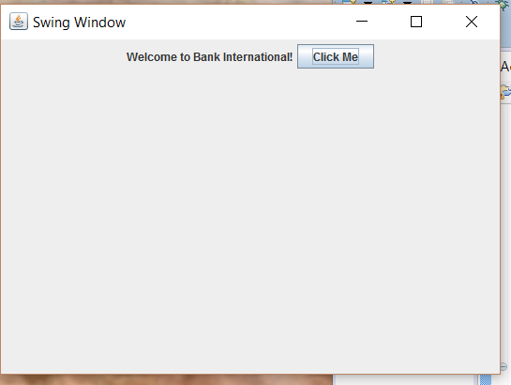

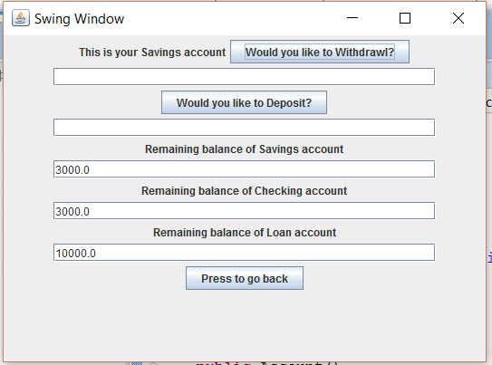

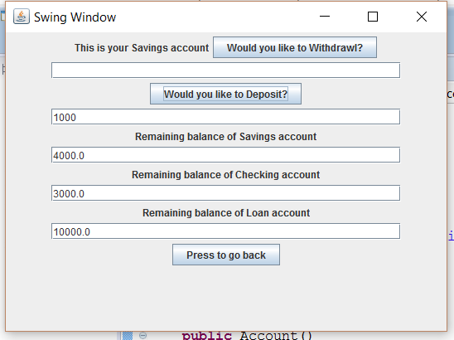

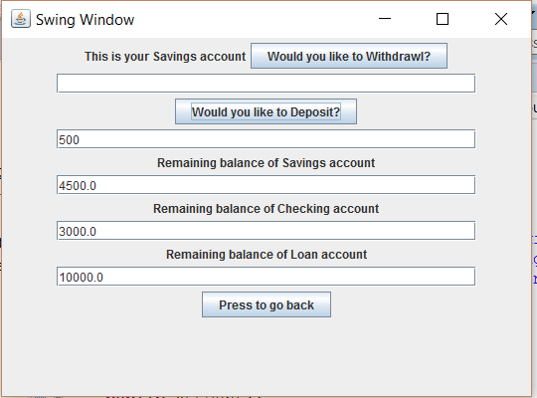

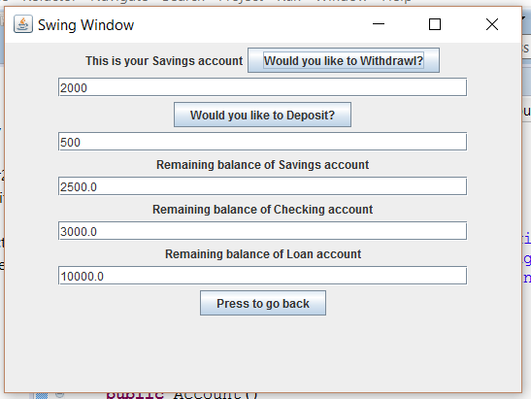

SNAPSHOTS FOR CHECKING ACCOUNT TRANSACTIONS

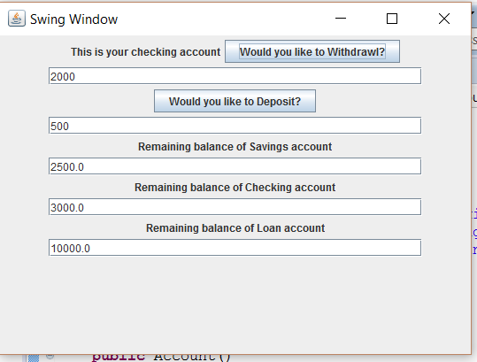

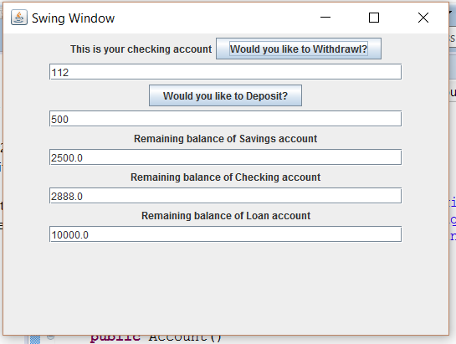

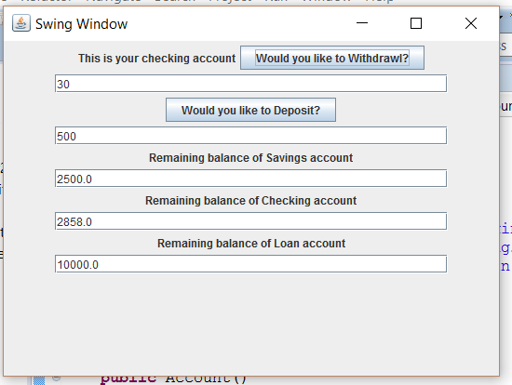

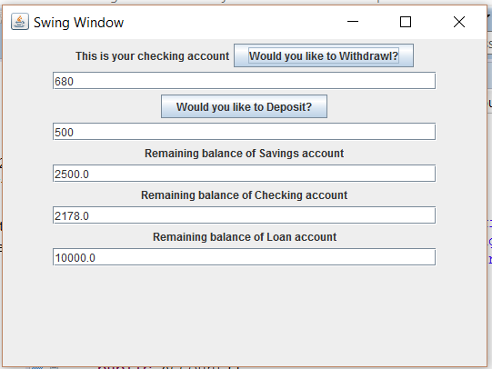

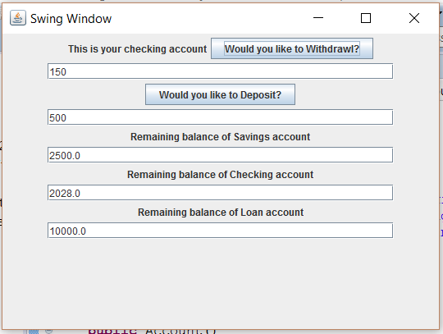

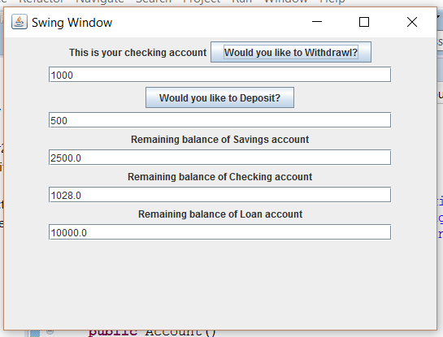

SNAPSHOTS FOR LOAN PAYMENTS TRANSACTIONS

